THE INDUSTRIAL DEVELOPMENT BOARD
OF THE CITY OF CHATTANOOGA

ECONOMIC IMPACT PLAN
FOR
THE BEND DEVELOPMENT PROJECT

- Authority for Economic Impact Plan. Industrial development corporations (“IDBs”) are authorized under T.C.A. § 7-53-312 to prepare and submit to cities and counties an economic impact plan with respect to an area that includes a project within the meaning of T.C.A. § 7-53-101 and such other properties that the IDB determines will be directly improved or benefited due to the undertaking of a project. T.C.A. § 7-53-312 authorizes cities and counties to allocate new incremental property tax revenues (the “Incremental Property Tax Revenues”), which arise from the area subject to the economic impact plan, to an IDB to promote economic development, to pay the cost of projects and other eligible costs and/or to pay debt service on bonds or other obligations issued by the IDB to pay the cost of projects and other eligible costs.
T.C.A. § 7-53-316 (the “Brownfield Increment Statute”) authorizes cities and counties to allocate the non-school portion of new incremental local sales tax revenues (the “Incremental Sales Tax Revenues”) with respect to a brownfield redevelopment project. Local sales tax revenues means taxes received by the municipality pursuant to the 1963 Local Option Revenue Act, T.C.A. § 67-6-701, et seq. A brownfield redevelopment project means the development or redevelopment in one or more phases of all or a portion of a parcel or parcels of contiguous, adjacent or related properties that contain at least one brownfield site, as defined in the Brownfield Increment Statute, and also includes a project described in T.C.A. § 7-53-101 and certain other amenities. Incremental Property Tax Revenues and Incremental Sales Tax Revenues are referred to in this Economic Impact Plan (this “Plan”) collectively as “Incremental Revenues”.
- The Project. Urban Story Ventures LLC, as developer on behalf of its affiliates thereof and its future affiliated entities that may engage in such development (collectively, the “Developer”) intend to develop approximately 90 acres as a mixed-use development in the City of Chattanooga (the “City”) to be known as The Bend, which development (the “Development”) is also sometimes referred to as portion of the One Westside Plan. The current conceptual site plan for the Development is attached hereto as Exhibit A. As shown by the conceptual site plan, the Development is expected to include a number of different components, such as retail enterprises, hotels, offices, parking facilities and recreational facilities, each of which constitute a “project” within the meaning of T.C.A. § 7-53-101. The Development is expected to also include certain additional uses, such as residences, a park and a riverwalk, and includes an existing manufacturing facility. The Development will be a mixed-use development with each component supporting other components in order to create an integrated mixed-use community, and therefore each parcel within the Development, now existing or hereinafter created from existing parcels, will directly benefit from the development of these “projects.” Collectively, the projects that are eligible projects within the meaning of T.C.A. § 7-53-101 and that are expected to be located within the Development shall constitute the project that is required to be located within the Plan Area identified below, and such projects are referred to in this Plan as the “Project”.

In order to make the undertaking of the Project and the Development financially feasible, the Developer has requested the City and Hamilton County, Tennessee (the “County”) to approve this Plan that has been submitted by the Industrial Development Board of the City of Chattanooga (the “Board”), pursuant to Title 7, Chapter 53 of Tennessee Code Annotated, to provide Incremental Revenues to pay a portion of the costs of the Project, other eligible costs and/or to pay debt service relating to tax increment financing incurred to finance such eligible costs. This Plan also provides for the allocation of Incremental Property Tax Revenues to pay a portion of the cost of certain public projects, as are described below.

- Boundaries of Plan Area. The Development, including the Project, will be located in an area generally bounded by the Tennessee River to the west, Riverfront Parkway to the east, Mariner Way and MLK Boulevard to the north and W. 19th Street to the south with a small portion south of W. 19th Street (the “Plan Area”). The Plan Area is within the corporate limits of the City. The Plan Area is shown on Exhibit B attached hereto, and a list of the existing tax parcels that are in the Plan Area are attached hereto as Exhibit C. Upon adoption of this Plan, the Plan Area is hereby declared to be subject to this Plan, and the Project that will be located within the Plan Area is hereby identified as the required project for purposes of T.C.A. § 7-53-312 and T.C.A. § 7-53-316. The Plan Area only includes the Project and other parcels that will directly benefit from the Project due to the creation of public infrastructure necessary for the Project and through interconnectivity of the multi-use development that includes the Project. The entire Plan Area is also a brownfield site within the meaning of T.C.A. § 7-53-316, and therefore an allocation of Incremental Sales Tax Revenues pursuant to T.C.A. § 7-53-316 is also permitted.

- Financial Assistance. The Board will provide financial assistance to the Project by applying a portion of the Incremental Revenues in the manner described in this Plan to pay debt service with respect to tax increment financing issued by the Board to finance and/or pay and/or reimburse the Developer for the payment of all or a portion of certain costs that will be incurred in connection with public infrastructure serving the Plan Area. These costs will relate to the design, construction and installation of public infrastructure to be made in, adjacent to, or serving the Plan Area that the Board deems necessary to serve the Project, which shall include all public infrastructure in the Plan Area and to improve Riverfront Parkway. For costs eligible to be funded with Incremental Property Tax Revenues, public infrastructure shall have the meaning given to such term in T.C.A. § 9-23-102(16), which includes roads, streets, publicly-owned or privately-owned parking lots, facilities or garages, traffic signals, sidewalks or other public improvements that are available for public use, utility improvements and storm water and drainage improvements, whether or not located on public property or a publicly-dedicated easement. For costs eligible to be funded with Incremental Sales Tax Revenues, public infrastructure shall have the meaning given to such term in T.C.A. § 7-53-316(f)(5)(A), which includes costs for all roads, streets, sidewalks, access ways, ramps, bridges, landscaping, signage, utility facilities, grading, drainage, parks, plazas, greenways, public parking facilities, public recreational facilities, public educational facilities, public meeting facilities, and similar improvements. The Board, subject to the terms of one or more development agreements to be negotiated with the Developer, will pay and/or reimburse the Developer for all or a portion of the cost of such public infrastructure. Pursuant to such development agreements, the Board may also agree to reimburse the Developer for costs incurred in connection with the preparation and approval of this Plan that the Developer is required to pay pursuant to the Board’s policies. In connection with any tax increment financing payable in whole or in part from Incremental Revenues as authorized herein, the proceeds of such tax increment financing may also be used to pay interest during construction to the extent permitted by law, the establish of reasonable reserves to pay debt service and all other costs relating to the issuance of such tax increment financing.

Because it is expected that Incremental Revenues allocated pursuant to this Plan would only be used to pay public infrastructure costs as defined in T.C.A. § 9-23-102 or to pay debt service on tax increment financing incurred to finance such costs, it is not expected that a determination from the applicable officials of the State of Tennessee (the “State”) will be required pursuant T.C.A. § 9-23-108 as to the use of such Incremental Revenues to pay any costs on private property that are not public infrastructure costs.

As described in this Plan below, only a portion of the Incremental Property Tax Revenues shall be applied to pay costs relating to the Project. The remaining portion of the Incremental Property Tax Revenues will be allocated to pay the cost of certain public projects in the downtown area of the City. Each of these public projects will constitute an eligible project within the meaning of T.C.A. § 7-53-101. This remaining portion of the Incremental Property Tax Revenues will be allocated to pay the cost of such projects pursuant to one or more intergovernmental agreements between the Board, the City, the County and the Chattanooga Housing Authority (“CHA”). The specific public projects with respect to which Incremental Property Tax Revenues are expected to be applied include a downtown career and technical school that will help provide educational opportunities to residents of the County, including residents in the Development, a fire station that may be constructed by the City to serve the area that will include the Development and public infrastructure and public buildings for the redevelopment of an affordable housing project by CHA adjacent to the Development called Westside Evolves (collectively, the “Public Projects”), provided, however, that no Incremental Revenues shall be allocated to CHA pursuant to this Plan unless the City Council of the City approves a relocation plan for current residents of CHA that will be affected by the Westside Evolves project as shall be set forth in more detail in an intergovernmental agreement.

- Expected Impact on the City and the County. The Development, which includes the Project is expected to promote significant economic development in this area by yielding more than $4 billion in capital investment through utilization of commercial, residential, office, hotel, dining, entertainment, recreational and mixed-use properties. In addition, it will emphasize health and wellness through open greenspace, parks and an enhanced Riverwalk that will draw residents and tourists to the City and the County. It is anticipated that the Project will become a catalyst for further development of the surrounding areas and will support the continued growth of the downtown area of the City.

It is also expected that the Project will accelerate the timing of the improvement of this area relative to development that might have occurred without the Project. These activities will be a major catalyst in making the Plan Area a prominent feature of the civic, economic, recreational and cultural life of the City and the County, providing a gathering place for people to park, work, live, shop and dine.

The Developer retained Younger Associates to conduct an Economic Impact Analysis of the Development. That Economic Impact Analysis (the “Younger Study”) is attached to this Plan as Exhibit D. As is shown in the Younger Study, it is anticipated the development, which includes the Project will create a significant number of construction jobs during construction of the Project. A significant part of the Project will be commercial office, residential, retail, restaurant, and hotel uses, which will result in significant long-term job creation, and specifically, the creation of over 2,000 jobs with competitive wages. The Younger Study includes projections of the direct and indirect jobs expected to be created due to the Development based upon traditional economic development metrics.

As is also shown in the Younger Study, the City and the County are also expected to realize additional tax receipts because of the Development, including the Project. Even after the allocation of Incremental Revenues provided for in this Plan to the Board, substantial new property tax revenues, sales tax revenues and hotel tax revenues will be created by the Development that will be immediately available to the City and the County. The projections of these additional tax receipts are detailed in the Younger Study, which is incorporated by reference into this Plan.

The City expects to incur additional operating expenses and additional capital costs relating to the undertaking of the Development. The operating expenses include additional costs relating to police and fire protection as well as other City services. Based upon the Younger Study, the City anticipates significant additional new revenue sources due to the undertaking of the Development, including additional local sales taxes, additional property taxes that are retained by the City as is described below, hotel taxes and other revenues. These additional revenues are expected to be sufficient to offset any additional costs to the City from the Development, as estimated by City staff, and the net effect of the undertaking of the Development is expected to have a positive financial impact to the City and the County.

6. Distribution of Taxes and Tax Increment Incentives
(a) Distribution of Property Taxes. In accordance with and subject to T.C.A. § 7-53-312(c) and T.C.A. § 9-23-101 et seq. (collectively, the “Tax Increment Act”), real property taxes (but not including personal property taxes, which shall not be subject to allocation to the Board) imposed on the real property located within the Plan Area will be allocated and distributed as provided in this section. The property taxes assessed by the City and the County on each tax parcel of real property within the Plan Area will be divided and distributed as follows (subject to the commencement of allocation as to each parcel as is permitted below):
(i) The portion of the real property taxes that were payable with respect to each tax parcel for the year prior to the date of approval of this Plan (the "Base Tax Amount") shall be allocated to and, as collected, paid to the City and the County as all other taxes levied by the jurisdictions on all other properties; provided, however, that in any year in which the taxes on the property within the applicable portion of the Plan Area are less than the Base Tax Amount, there shall be allocated and paid to the City/County only the taxes actually imposed. The Base Tax Amounts for each tax parcel within the Plan Area are shown on Exhibit D attached hereto.
(ii) The portion of the real property taxes payable with respect to each tax parcel that constitutes Dedicated Taxes (as defined below) and is not included in Base Tax Amount shall be retained by the City and the County for their respective debt service funds. “Dedicated Taxes” are defined in T.C.A. § 9-23-102 of the Tax Increment Act, as “that portion of property taxes, if any, designated by a taxing agency to pay debt service on the taxing agency's debt.” “Taxing agency” is defined in the Tax Increment Act as “any county, city, town, metropolitan government or other public entity that levies property taxes on property within a plan area and that has approved the plan,” which would include both the City and the County. To the extent that the amount of Dedicated Taxes is not determined by resolution of the governing body of either City or the County, the amount of Dedicated Taxes may be determined by a certificate of the chief financial officer of the City or County or in such reasonable manner as either City or the County shall select.
(iii) With respect to the City, the excess of real property taxes as to each parcel over the Base Tax Amount less the greater of (i) the Dedicated Taxes or (ii) forty percent (40%) of the property taxes in excess of the Base Tax Amount (such remainder being the "City Incremental Property Tax Revenues") shall be, as collected, paid into a separate fund or funds of the Board, created to hold such payments until such amounts are applied as provided in a development agreement with the Developer or intergovernmental agreements as described above (A) to pay or reimburse eligible costs relating to the Project and/or (B) to pay debt service on the obligations expected to be issued by the Board to finance such costs and/or (C) to pay or reimburse costs of the Public Projects, provided that the costs relating to the Project and other eligible costs shall be limited to forty-seven percent (47%) of City Incremental Property Tax Revenues, and may be less in the event that Developer does not satisfy the requirements of the development agreement.
(iv) With respect to the County, the excess of real property taxes as to each parcel over the Base Tax Amount less the (i) the Dedicated Taxes plus (ii) that portion of the real property taxes designed by the County for school operating purposes (such remainder being the "County Incremental Property Tax Revenues") shall be, as collected, paid into a separate fund or funds of the Board, created to hold such payments until such amounts are applied as provided in a development agreement with the Developer or intergovernmental agreements as described above (A) to pay or reimburse eligible costs relating to the Project and/or (B) to pay debt service on the obligations expected to be issued by the Board to finance such costs and/or (C) to pay or reimburse costs of the Public Projects, provided that the costs relating to the Project and other eligible costs shall be limited to forty-seven percent (47%) of County Incremental Property Tax Revenues, and may be less in the event that Developer does not satisfy the requirements of the development agreement.
(b) Distribution of Incremental Sales Taxes. In accordance with and subject to T.C.A. § 7-53-316, fifty percent (50%) of the Incremental Sales Taxes shall be, as collected, paid into a separate fund or funds of the Board, created to hold such payments until such amounts are applied as provided in a development agreement with the Developer (A) to pay eligible costs relating to the Project and/or (B) to pay debt service on the obligations expected to be issued by the Board to finance such costs.
(c) General Allocation Provisions.
The Board is authorized to make all calculations relative to the allocation of Incremental Property Tax Revenues on the basis of each parcel within the Plan Area instead of on an aggregate basis. As permitted by the Tax Increment Act, the Board is also authorized to separately group one or more parcels within the Plan Area for purposes of calculating and allocating Incremental Property Tax Revenues, and in such case, the allocation of Incremental Property Tax Revenues shall be calculated and made based upon each such parcel or group of parcels and not the entire Plan Area.
The allocations of Incremental Revenues are further subject to the retention or payment of any applicable administrative expenses and fees of the Board, the City or the County that are permitted by applicable law or applicable policies.
The Base Tax Amount and the Base Sales Tax Amount will be separately established for each parcel, as each such parcel may be subdivided, and the Board will make calculations and allocations of Incremental Revenues for each parcel separately (or with respect to groups of parcels as provided above). The parcels within the Plan Area may be further divided, in which case such parcels, as divided, will be treated separately, and the Base Tax Amount with respect to each tax parcel that is subdivided shall be allocated to each subdivided parcel on a pro-rated basis using either the acreage of each subdivided parcel as a percentage of the total acreage of the original tax parcel or using the relative then current real property tax amounts, as the Board may determine.
The Board is also authorized to designate, by notice to the City and the County, that the allocation of Incremental Property Tax Revenues for each parcel or group of parcels within the Plan Area may begin in different years from the allocations of Incremental Property Tax Revenues for other parcels or groups of parcels within the Plan Area. This approach allows the Board to match Incremental Property Tax Revenues from the development of each of the parcels with debt service payments. The allocation of Incremental Property Tax Revenues for each parcel within the Plan Area will be subject to the maximum allocation period as provided below and pursuant to one or more development agreements to be entered into between the Board and the Developer.
Allocations of Incremental Property Tax Revenues shall be made (i) as to revenues derived from non-delinquent taxes, within sixty (60) days of the date such taxes are due without penalty for each tax year and (ii) as to revenues derived from delinquent taxes, within sixty (60) days from when such taxes are collected by the City and County. Allocations of Incremental Sales Tax Revenues shall be made by the City within sixty (60) days of the date such revenues are received by the City.
- Limitations on Allocations.

(a) Property Tax Revenues. The aggregate amount of Incremental Property Tax Revenues allocated to the Board pursuant to this Plan, exclusive of amounts allocated for the Public Projects outside the Plan Area, shall not in any event exceed $100,000,000 plus interest on any debt incurred by the Board payable from Incremental Property Tax Revenues subject to the limitation below.

(b) Sales Tax Revenues. The aggregate amount of Incremental Sales Tax Revenues allocated to the Board pursuant to this Plan, exclusive of amounts allocated for the Public Projects outside the Plan Area, shall not in any event exceed $15,000,000 plus interest on any debt incurred by the Board payable from Incremental Property Tax Revenues subject to the limitation below.

(c) Interest Costs. The aggregate amount of Incremental Revenues allocated to the Board pursuant to this Plan to pay interest costs related to debt obligations payable from Incremental Revenues for costs related to development in the Plan Area shall not in any event exceed $20,000,000.

(d) Public Infrastructure Costs. The aggregate costs paid for public infrastructure relating to the Project from Incremental Property Tax Revenues shall not exceed fifty percent (50%) of such costs to be determined in the manner set forth in the development agreement between the Board and the Developer, provided that this fifty percent (50%) limitation shall not apply to costs paid for with Brownfield Sales Tax Revenues.

- Time Period of Allocations.

(a) Property Tax Revenues. Incremental Property Tax Revenues will be allocated to the Board as provided in this Plan for a period as to each parcel or groups of parcels in the Plan Area for a maximum period of twenty (20) tax years, with the commencement of each allocation period as to each parcel being determined as is provided in the development agreement between the Board and the Developer. Until an allocation of Incremental Property Tax Revenues commences as to a parcel as described above, no Incremental Property Tax Revenues shall be allocated to the Board as to such parcel. The allocation of Incremental Property Tax Revenues shall continue until all obligations are satisfied and Board expenditures have been paid subject to the maximum allocation period and the limitations above. The allocation period for Incremental Property Tax Revenues as to each parcel within the Plan Area shall commence not later than (i) the first full calendar year after completion of the initial improvements on such parcel or (ii) the 2030 calendar year, all as to be provided in more detail in the development agreement.

(b) Brownfield Sales Tax Revenues. The allocation period of Brownfield Sales Tax Revenues shall not exceed twenty (20) years. The allocation period for the Brownfield Sales Tax Revenues shall commence as required by applicable law and as is agreed upon in the development agreement between the Board and the Developer provided that such allocation period shall commence not later than calendar year 2029.

- Debt Issuance and/or Reimbursement of Eligible Costs. The Board may borrow funds through the issuance and sale of notes, bonds or other obligations of the Board in one or more issuances, to pay for or reimburse eligible costs (as described above) relating to the Project. The Board may pledge all or a portion of the Incremental Revenues allocated to the Board pursuant to this Plan to the payment of any such notes, bonds or other obligations, including, without limitation, principal and interest thereon. In no event will the obligations issued by the Board be considered a debt or obligation of the City or the County in any manner whatsoever, and the source of the funds to satisfy the Board's payment obligations thereunder shall be limited, as to the Board, solely to the Incremental Revenues and shall otherwise be non-recourse to the Board. Any debt obligation of the Board may be refinanced by the Board at any time as permitted by the Tax Increment Act, and upon such refinancing, available Incremental Revenues shall be applied to the payment of such refinancing debt to the extent such Incremental Revenues were to be used to pay the debt that is being refinanced. Incremental Revenues may also be applied directly to pay or reimburse eligible costs relating to the Project. The application of Incremental Revenues shall be governed by one or more development agreements to be entered into by the Board and the Developer and/or affiliates of the Developer providing for the terms under which the Board would incur debt payable from the Incremental Revenues or otherwise agree to pay or reimburse eligible costs relating to the Project.
- Finding of Economic Benefit. The Board, the City and the County, by the adoption of this Plan, find that the Project, as a whole, is within an area that could provide substantial sources of tax revenues and economic activity to the City and the County, and find that the use of the Incremental Revenues, as described herein, is in furtherance of the promotion of economic development in the City and the County, and that the use of the Incremental Revenues, as provided herein, will develop trade and commerce in and adjacent to the City and the County, will contribute to the general welfare, and will alleviate conditions of unemployment. In addition, it is determined that the construction and equipping of the Project will be necessary and advantageous to the Board in furthering the purposes of the Tax Increment Act and that the use of the Incremental Property Tax Revenues and the Incremental Sales Tax Revenues to pay the costs authorized herein and/or to pay debt service on the obligations expected to be issued by the Board to finance all or a portion of such costs is necessary and desirable under T.C.A. §§ 9-23-102(16).
- Approval Process.
- Pursuant to T.C.A. §§ 7-53-312 and 7-53-316, the process for the approval of this Plan is as follows:

- The Board shall hold a public hearing on this Plan after publishing notice of such hearing in a newspaper of general circulation in the City and the County at least two weeks prior to the date of the public hearing. The notice must include the time, place and purpose of the hearing as well as notice of how a map of the subject area may be viewed by the public. Following such public hearing, the Board shall submit the Economic Impact Plan to the City and County for their approval.

- The governing bodies of both the City and the County must approve this Plan for this Plan to be effective to both the City and the County. This Plan may be approved by resolution of the governing bodies of the City and the County, whether the local charter provisions of the City or County provide otherwise. If the governing body of either the City or the County fails to approve this Plan, this Plan will not become effective. If either of the City or County make any changes to this Plan in connection with their approval hereof, such changes must be approved by the Board following a public hearing related thereto, and such changes must also be approved by the other City or County, as applicable.

- Once the governing bodies of the City and the County has approved this Plan, the Plan and related documents shall be filed with the local taxing officials and the Comptroller of the State. Annual statements of incremental tax revenues allocated to the Board shall be filed with the State Board of Equalization. The Board will also comply with all other procedural requirements of the Tax Increment Act and other applicable laws.

- Although no approval of the State is expected due to the anticipated uses of Incremental Revenues, the Board, through its representatives, shall consult with the State with respect to the prospective uses of Incremental Revenues and to see any approvals from the State that the State deems advisable with respect to the application of such Incremental Revenues.

Exhibit A

Conceptual Site Plan

See map on following page

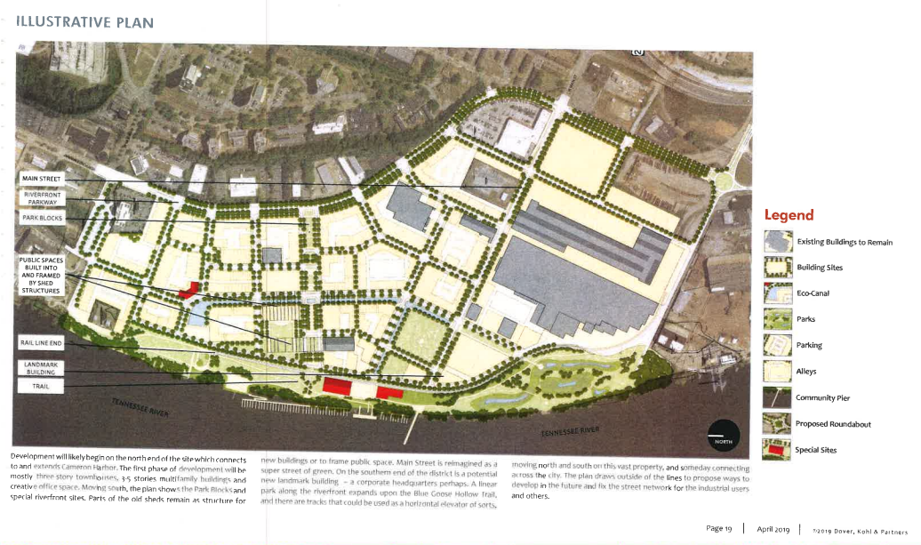

Exhibit B

Map of Plan Area
See map on following page
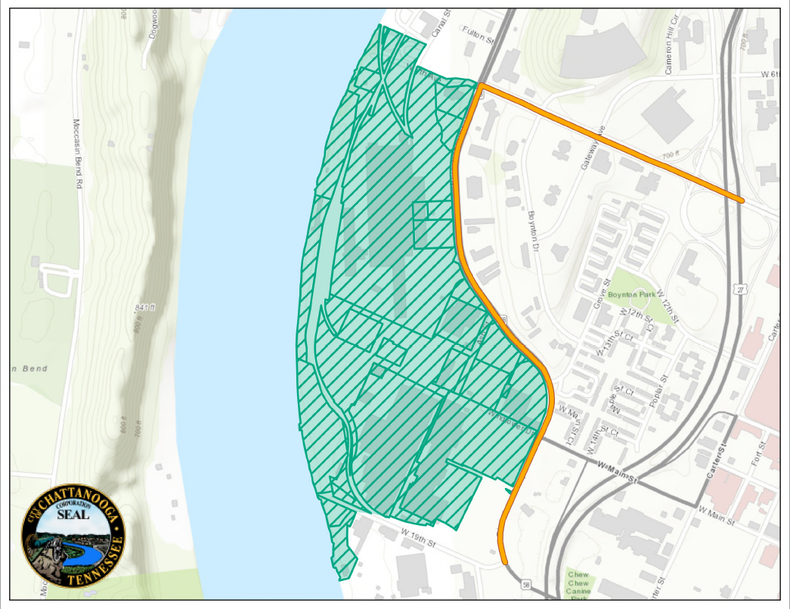

Exhibit C

Parcel Identification Numbers of Parcels in Plan Area and Base Taxes for Each Parcel

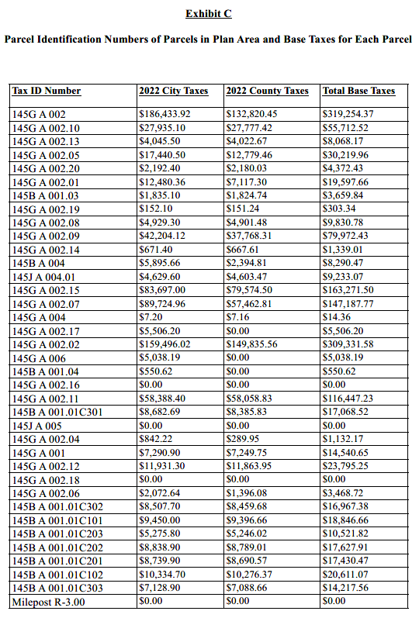

Exhibit D

Younger & Associates Economic Impact Study

See Attached

This study is provided separately due to its size

35941164.10

